**1. Introduction**

The *objective* of the proposed research is to combine complex systems modelling (novel statistical tools) and Reactive Transport Modelling (RTM) with select experiments to test hypotheses on the origin of the widespread increased in dissolved organic carbon (DOC) fluxes from forested headwater streams in the past decades. Potential causes for the increased DOC flux include changes in climate, land use or precipitation composition (i.e. recovery from acidification) and are debated but little focus has been given to the precise mechanisms. We focus on watersheds that have not been impacted by land use changes and *hypothesize* that stream water DOC flux increase is driven by the regionally observed recovery from acidification (i.e. the increase in pH and decrease in ionic strength of wet and dry deposition), and not by changes in regional climate (hypothesis 1).We furthermore hypothesize that DOC is released from soil aggregates that become unstable under these changing conditions (hypothesis 2) and that aggregate stability and DOC release is a function soil composition and mineralogy, leading to the varied responses (presence or absence of DOC increase) despite potentially similar regional forcings (hypothesis 3).

To test these hypotheses, we propose to mine stream water, climatic and soil data from 60 USGS, 5 US-Critical Zone Observatory (CZO) sites that span wide gradients in climatic forcings (tropical to semi-arid), bedrock lithologies (granitic, volcanic and sedimentary), and anthropogenic impact (acid deposition), as well as data from other national databases including topography, land cover, soil type. These datasets will be complemented with the collection of new, experimental data to allow for a comprehensive investigation of linkages between observed patterns, internal Critical Zone (CZ) drivers, external drivers and hypothesized processes. New data analysis tools will be used on these combined datasets for “data dredging”, which is a “Big Data” term for the search for patterns in huge datasets. Results from this step will help domain experts (here geochemists and hydrologists) to better visualize and identify patterns at the regional scale (>100km) to make potential linkages between external (climate, precipitation composition), internal drivers (e.g. the composition and structure of the CZ) and the response (DOC increase). Based on the data dredging results, RTM will be used on selected catchments to test hypotheses on the processes behind patterns at the catchment scale (km). Experiments will complement RTMs to isolate specific processes to test hypotheses at the macro to micrometer scale (mm-μm, Fig 1), which in turn may lead to more data dredging, expert knowledge and new hypotheses.

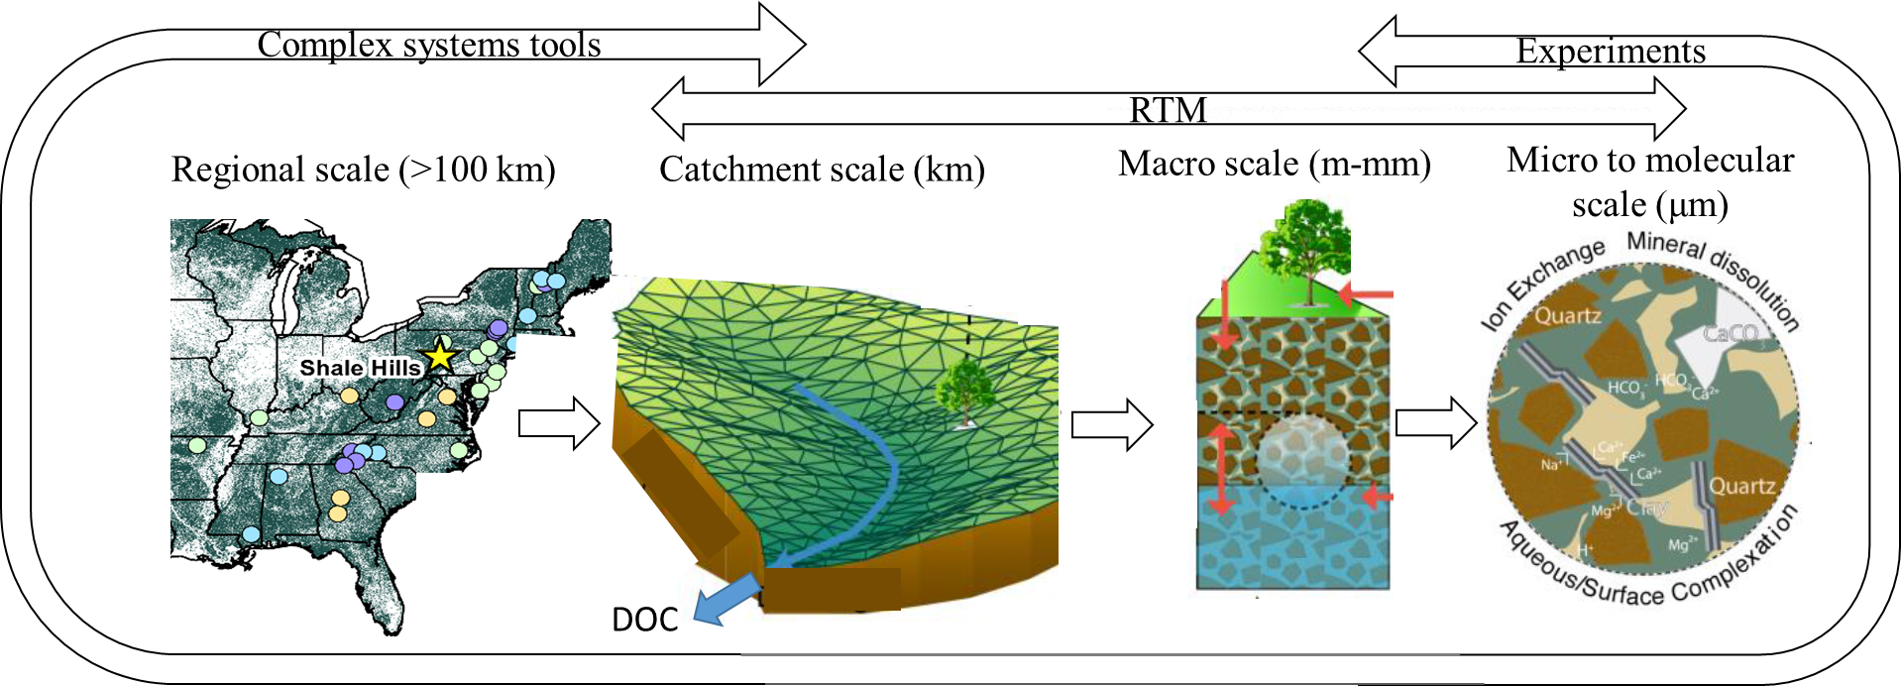

*Fig. 1. Complex systems tools, Reactive Transport Modelling (RTM) and experiments bride scales in low temperature geochemistry (modified after Bao et al. 2016).*

With this setup we will pursue the dual goal of i) testing specific hypotheses on stream water DOC increase over the past decades and ii) developing and testing a new approach for the integration of multi-scale data to advance low temperature geochemistry.

**1.1. Stream water DOC: critical to the carbon (C) cycle and a test case for integrative modelling across scales**

The dissolved fraction of organic carbon, transported by streams and rivers, plays an important role in the global C cycle (Aufdenkampe et al. 2011; Perdrial et al. 2014a; Schlesinger & Melack 1981). Increases in C in streams and rivers potentially contribute to rising atmospheric CO2 levels, which is one of the principal drivers of climate change (IPCC 2013). Additionally, when DOC reacts with chlorine-based disinfectants (typically used in water treatment), hazardous disinfection by-products can form that impact the quality of drinking water (Singer 1994). Covering large land areas, forested headwater catchments have disproportionate effects on DOC dynamics (MacDonald & Coe 2007) and are therefore closely monitored across the globe.

Over the last decades, several studies reported increased levels of DOC in forested streams across the northern hemisphere (Monteith et al. 2007; Porcal et al. 2009) and several processes have been proposed to explain observed patterns. For example, some studies indicate that increases in DOC are consistent with a climate change driver including changing temperature or hydroclimatic conditions (Eimers et al. 2008; Freeman et al. 2001; Lepistö et al. 2008; Worrall & Burt 2007). Other suggested drivers include changes in nitrogen deposition (Stuart 2005) or land management practices (Yallop & Clutterbuck 2009). Lastly, recovery from acidification is put forth as a general driver for observed changes in stream water DOC (De Wit et al. 2007; Evans & Monteith 2001; Hruška et al. 2009; Monteith et al. 2007).

However, some catchments exhibit increases in DOC effluxes despite lack of recovery (Oni et al. 2013) while others recover, but show no DOC flux increases (Löfgren & Zetterberg 2011). A reason for the contrasting explanation for presence and absence of stream water DOC increase was investigated by Clark et al., (2010) who concluded that spatial and temporal variation of various drivers may mask otherwise potentially compatible patterns. However, little focus has been given to the precise mechanisms of DOC release, which hinders investigations of the link between external drivers and processes behind DOC liberation: recovery from acidification (driver) can only lead to increased DOC (response) if the DOC liberation is sensitive to imposed changes (via a process that potentially varies with CZ structure, Fig 2).

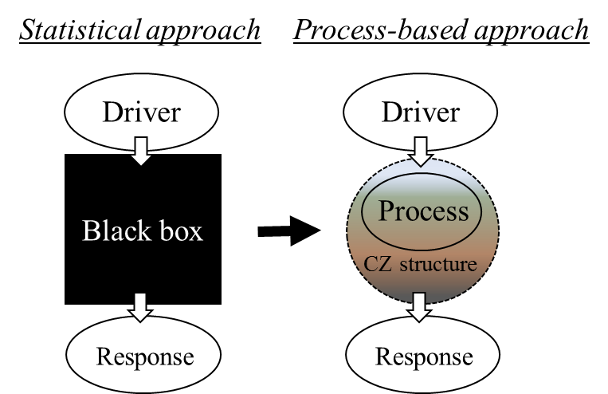

*Fig. 2. Statistical approaches (left) allow for the identification of links between regional drivers (e.g. change in precipitation composition or climate) and response (e.g. stream DOC increase). To further understand processes governing the nature of the driver-response dynamics, the black box needs to be opened using process based modelling and experiments.*

Drivers vs. coupled processes likely vary at different land and time scales, hence the stream water DOC phenomenon is an ideal testbed to address an overarching question in low temperature geochemistry and catchment science: how can we combine regional patterns (identified in Big Data and regional scale) with process based understanding (catchment to micrometer scale) to understand and eventually predict linkages between driver and response? Recent advances in RTM opened new avenues to exploring the links between macro and micrometer (and molecular) scale processes and a catchment scale response. For example, is recent research by Bao et al. (2016) the black box was opened to explain common observation of hysteresis in stream concentration-discharge relationships. In this case the catchment scale signal could be attributed to the molecular and macro scale process of cation exchange and mineral dissolution.

We propose to expand upon this research and to integrate regional drivers, CZ specific processes and observed changes in stream water C fluxes by combining statistical methods (regional scale), process-based modelling (catchment to molecular scale) and experimental methods (macro to molecular scale) using the example of stream water DOC dynamics.By doing so, we will not only test our specific hypotheses but also develop and test a template for bridging scales of observations- which is potentially transformative for catchment science.

**2. Background**

**2.1. A complex systems approach to mining the complexity of natural systems**

The Big Data revolution has had a transformative impact across virtually all academic disciplines (Alexander et al. 2015; Li et al. 2012). The recent emergence of new statistical and machine-learning algorithms have been driven, in part, by the advances in distributed computing and storage that accompany long-term monitoring, but more importantly, by the challenges in mining and analyzing these large, multi-scale, data-rich systems. These modern data analysis tools include a variety of machine learning algorithms, network analysis, evolutionary computation, non-parametric statistics (e.g., cluster analysis, classification, factor analysis, Bayesian analysis). They are data-driven such that they allow for the statistical analysis of complex data (i.e., input and corresponding output or response variables that are nonlinear, heterogeneous and cross-correlated), while limiting bias through premature input selection based on *a priori* assumptions regarding specific processes. Because these approaches are robust and flexible, applications are wide-spread and varied, but are increasingly used for environmental applications (Holmberg et al. 2006).

Complex systems tools present a robust data mining and dredging approach to systems that are too complex (or lack the physical understanding) to be initially modeled with process-based tools. These modern data analysis tools are used as a first assessment of multi-scale data on natural systems. Because the accounting for specific processes is not necessary, typical confirmation bias (we only find what we are looking for) is avoided. However, to avoid one of the major pitfalls of working with Big Data (i.e., finding correlations in very large data sets without an understanding of the causation) the output of data dredging must be performed in concert with domain experts (here geochemists and hydrologists) who provide real insight about the observed patterns and problem at hand. A fundamental change in experimental design is one of the important shifts emerging from the Big Data movement: traditional trajectories of developing a hypothesis, planning experiments, collecting and analyzing data have become more circular in that hypotheses can be developed on Big Data analyses. From there, new process-based models can be developed and tested, which in turn, generates the need to collect more data, plan new experiments, and so on.

Research by co-PI Rizzo (Pearce et al. 2013) on water quality in lake systems exemplifies the process of iterative use of modern data mining tools to guide hypotheses generation. Because these complex systems tools do not require prior identification of specific processes or drivers, the analyses are less biased and can identify complex patterns and correlations leading to questions/hypotheses that have not yet been asked. In this lake monitoring study, the complex systems analysis (here an unsupervised network) found the typical linkages between water temperature, nitrogen:phosphorus ratios and sediment anoxia as drivers for toxic blooms. However, the analysis also identified an additional set of conditions at the lake-sediment water interface necessary for initiating a bloom that had not been identified to date, and resulted in adapted sampling strategies, as well as substantial changes in the understanding of the Microcystisalgal blooms.

Machine learning tools can be used to **identify main drivers** (input variables) that produce a given stream water solute pattern (output or response variables). In addition to reducing data dimensionality and facilitating visualization, sensitivity analyses can be performed on the input drivers. We envision this approach as being uniquely suited to analyzing and classifying catchment C dynamics and testing our hypotheses. For this combinations of catchment input parameters (e.g. precipitation amount and composition, bedrock and soil composition, stream water composition) may be identified in an iterative machine-learning approach to produce output that matches measured DOC concentrations. The relative weights and significance associated with input parameters represent important information that can be used to constrain other, physics- or process-based models.

**2.2. Multi-scale critical zone (CZ) data**

We propose to use data from national databases including topography, land cover, soil type from USGS National Elevation Dataset (NED), the Soil Survey Geographic (SSURGO) database, and the National Land Cover Database (NLCD). Furthermore we will use USGS Hydro-Climatic Data Network (HCDN) datasets, which include a large abundance of high quality Big Data on stream water quantity (i.e., discharge) and composition (including volume weighted DOC). These data are uniquely suited to exploring patterns in C export because they were collected over several decades at consistent sampling intervals in areas that have seen minimal human impact. However, data collection efforts at USGS HCDN sites do not sample event-scale response, which is particularly important for flow path dependent C delivery to streams. Furthermore, more detailed information on, for example, soil composition is available for many, but not all sites. In contrast, the so-called common measurement (CM) data from CZO’s comprise data on energy (e.g. radiation), water (e.g. precipitation or discharge), solutes and sediments fluxes for the CZ system ranging from the tree tops and the actively cycled ground water, and include event-based sampling (Chorover et al. 2012; Harpold et al. 2013). The great advantage of CZO data is that in addition to fluxes and reservoirs of water, energy and C, there is extensive data on catchment characteristics such as soil thickness and hydraulic properties, bedrock lithology and vegetation structure are available. However, CZOs are young with less than a decade of data available for any given site. Combining data from multiple CZOs with longer-term USGS data that span a wider gradient of climate and bedrock lithology, and CZ system-scales will add statistical power and help leverage recent developments in complex systems statistical tools to explore the proposed approach to identify drivers of stream water C export (Fig. 3).

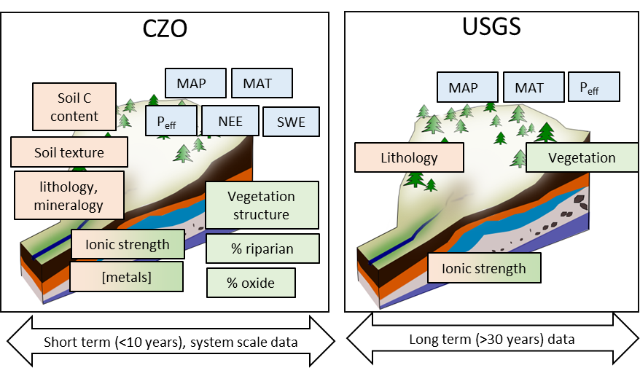

*Fig. 3. Examples of input variables from USGS and CZO sites complementing each other: USGS data include long-term quantification of water quality and discharge while common measurements from CZOs include data on system energy, water and carbon inputs and outputs as well as reservoirs for short time scales.*

Taking advantage of the synergistic power of various datasets was challenging in the past, however, mentioned novel and non-parametric statistical analyses we propose are uniquely adapted to do exactly this.

**2.3. Reactive Transport Modelling at the catchment scale: looking into the black box**

While complex system tools extract patterns and identify key drivers from a top-down, data-based approach, process-based models complement complex system tools by offering mechanistic insights on nonlinear coupling and feedbacks among multiple competing processes operating at the watershed scale. Although these spatially-explicit models suffer from the limitations “of nonlinearity, of scale, of uniqueness, of equifinality, and of uncertainty” (Beven 2001a; Beven 2001b; Ebel & Loague 2006) and can easily become computationally expensive, they also provide tools to extrapolate to other conditions and for predicting watershed responses under “what if” scenarios.

Process-based model development in hydrology and biogeochemistry communities has largely taken parallel routes. Hydrologists have long developed distributed models to explicitly simulate hydrological processes at the watershed scale while typically not taking into account reaction processes (Abbott et al. 1979; Gan et al. 2006; James 1972; Jarboe & Haan 1974; McDonnell et al. 2007; VanderKwaak & Loague 2001). In contrast, reactive transport models have been developed for decades in subsurface biogeochemistry; however they rarely interface with surface hydrology and surface-groundwater interaction processes (MacQuarrie & Mayer 2005; Steefel et al. 2005). Spatially explicit models across hydrology and biogeochemistry communities have only recently begun to emerge (Bao et al. 2016; Beisman et al. 2015; YEH et al. 2006).

Co-PI Li’s group has recently developed RT-Flux-PIHM that enables the simulation of coupled land-surface interactions, hydrological and biogeochemical processes that ultimately control solute export (Bao et al. 2016). RT-Flux-PIHM has enabled resolving the long-standing puzzle of chemostasis in hydrgeochemistry, i.e., the relatively small concentration variation compared to orders of magnitude variations in discharge for geogenic species (Na, Si, Ca, and Mg) in forest catchments (Clow & Mast 2010; Godsey et al. 2009). Model and data integration suggest that chemostasis arises from synchronized responses of clay dissolution rates (releasing geogenic species) and water storage corresponding to changing surface hydrological conditions (Bao et al., 2016b). This explanation from an integrated watershed modeling approach has challenged previous thinking on the important role of soil buffering capacity/equilibrium in determining stream water solute fluxes (Clow & Mast 2010; Maher 2011). In the proposed work, soil-DOC-water interactions will be represented in the reaction network informed by the complementing column experiments as described in the later sections integrating physical and geochemical characteristics of soil aggregates and DOC. These soil processes will be coupled with watershed hydrological dynamics to enable predictive understanding of DOC export, as well as identification of key processes and emergent behavior.

**2.4. From soils to streams: the importance of micro and molecular scale processes**

Streams integrate complex and coupled hydrological and biogeochemical processes at hillslopes, riparian areas, the hyporheic zone and the stream itself (Lohse et al. 2009). In forested catchments, stream DOC is mostly allochtonous (produced elsewhere) and typically sourced from organic rich soils of hillslopes and riparian areas (Aitkenhead-Peterson et al. 2003; Boyer et al. 1997; McDowell et al. 2006). Carbon in soils (soil organic matter=SOM) is stabilized via chemical, physical and biological processes operative at the molecular to macro scale but the connection to the overall ecosystem is more and more appreciated (Lehmann et al. 2007; Schmidt et al. 2011). As such, SOM stability and associated DOC production cannot be investigated in isolation from the CZ context, nor can it be resolved without taking the micron and molecular scale into account.

The dissolved fraction of C in soils is typically sourced from leaf litter and SOM, which in turn is associated with organo-mineral aggregates (Kaiser & Guggenberger 2000; Lehmann et al. 2007; Six et al. 2000). These aggregates protect C from microbial attack often by physically shielding C with soil minerals especially clays. Clay minerals and (oxy)hydroxides of Fe, Al, and Mn, are important soil constituents and have high specific surface area (10–800 m2 g-1), variable surface charge (pH dependent positive and negative charge, permanent layer charge) and reactive surface functional groups, which makes them effective multi-tools for sequestering colloids and otherwise dissolved species including C (Fig. 4, Chorover et al. 2007). I interaction with these short range order (small) minerals, solutes and organic matter leads to the formation of aggregates that stabilize otherwise labile carbon (Mikutta et al. 2006); hence, soil clay and iron oxide content is an important control for aggregation (Kalbitz et al. 2005; Thaymuang et al. 2013).

*Fig. 4. Soil organic matter (SOM) as precursor of stream water dissolved organic carbon (DOC). SOM is stabilized in organo-hetero aggregates in soils that include minerals, surface coatings and microorganisms (modified from Chorover et al. 2007).*

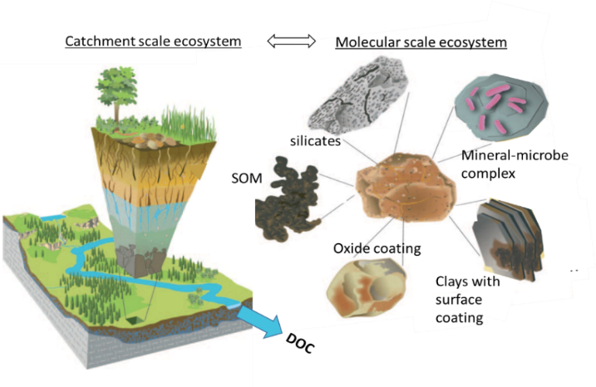

Whether soil DOC is sourced directly from leaf litter or from SOM, the chemistry of percolating soil solution plays an important role (Kalbitz et al. 2000). DOC can be stabilized on mineral surfaces via electrostatic interactions but desorb if solution chemistry changes. For example, the change in type and amount of solutes in soil solution can lead to competition for sorption sites leading to release of certain aggregate constituents (Sokolova & Alekseeva 2008). Change in ionic strength (I) and pH also fundamentally impact colloidal interactions and aggregation: increased I (e.g. during acidification) leads to the compression of the charged layer around an ion (i.e. diffuse double layer) so that attractive forces overcome repulsive forces (Derjaguin & Landau 1941; Verwey 1947). As a result, increases in I lead to coagulation and the stabilization of larger colloidal associations and aggregates (Lagaly 2006). Furthermore, increased proton concentration supplies positive changes that can bridge between negatively charged clays, equally aiding aggregation. In acid impacted soils a reversal of I and pH could therefore lead to the dispersion of such colloidal associations, aggregates and associated C. However, an increase in soil pH can also aid aggregation initiating the precipitation of metal (oxy)hydroxides (Sposito 2004), hence the precise mechanisms of C release from aggregates are complex and to date not fully investigated.

The soil chemistry community has investigated the role of aggregates in C stabilization for over a decade; however, the effect of these micron and molecular scale processes on the next scale (i.e. catchment DOC effluxes) has not been investigated. One reason for this disconnect could be difficulty with crossing disciplinary boundaries as well as scales. However, determining the necessary scale to address a specific question, or in turn, to determine the “reach” of a geochemical process beyond the scale of observation is fundamental to geochemistry and CZ science (Perdrial et al. 2015) and is addressed here.

**3. Changes based on past reviews**

Investigating the drivers of DOC exports in forested catchments using a variety of new statistical (Big Data) methodologies and mining hydrobiogeochemical data from USGS and CZO sites was considered novel, timely, and a strength of the proposed project. Leveraging data from NSF facilities paired with resources of other government agencies and the broader impact activity was viewed as another strength along with the multidiciplinatiy of our team. We build on these strengths and modified both the proposed research activities and proposal organization guided by the reviewers’ suggestions and constructive criticisms. Specifically, reviewers suggested the following:

*1) We did not provide details on how we will combine CZO and USGS data. W*e have now clarified in the workplan how these datasets are complimentary and how non-parametric statistical analyses relax the assumptions needed for traditional statistics (e.g., normality, input variables that are not correlated).

*2) Bioavailability of C was considered too transient to allow for testing our hypotheses.* We have shifted our focus away from bioavailability of dissolved C; and no longer propose to quantify bioavailability using spectral methods and incubations. Instead we propose to focus on DOC fluxes and volume weighted concentrations as suggested by reviewers.

3) *The work plan was not sufficiently detailed and the proposal organization unclear*. We have reviewed each step of the research work plan and supplied methodological details along three questions to aid organization.

**4. Hypotheses and Approach**

We will test the hypothesis that wide spread increases in DOC fluxes from forested headwater streams is a function of recovery from acidification (hypothesis 1) and that this C is released from organo-mineral aggregates of near stream soils (hypothesis 2). Furthermore we hypothesize that processes leading to C release are modulated by CZ characteristics, especially soil geochemical properties such as metal content and mineralogy. As such, CZ structure drives the varied responses (presence or absence of DOC increase) to one driver (change in precipitation composition, hypothesis 3).

We will use existing and newly collected data with three principle approaches (complex systems tools, RTM and experiments) to investigate this multi-scale problem. Each of these approaches is adapted to a different scale and its inherent complexity; i.e. complex systems analysis is adapted to handle large and complex datasets that will focus on identifying regional patterns and test hypothesis 1. The identification of patterns then allows for a targeted investigation using process-based approaches on a reduced number of sites to test hypothesis 2. RTMs have recently expanded to probe processes at the individual catchment scale and are uniquely situated to test hypotheses at this scale. Lastly, experiments have the advantage of reduced complexity to isolate specific processes that in turn can inform back to further our understanding of catchment and regional scale low temperature geochemistry testing hypothesis 3. While these approaches will inform each other, they will be used independently to investigate a targeted scale. Our working assumption is that results from different approaches will overlap (Fig. 5a) i.e. that results from the statistical modelling will be confirmed with RTMs and that experiments will identify and confirm specific processes important to different scales of observation.

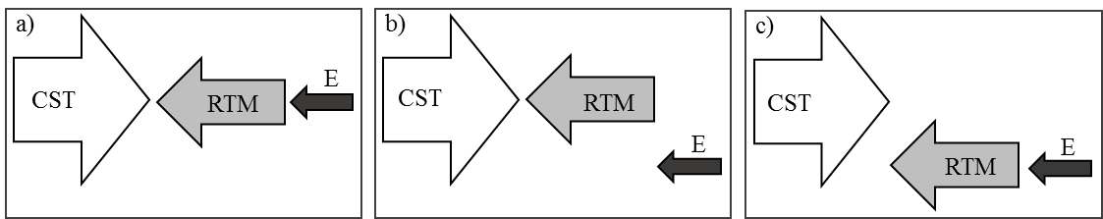

*Fig. 5. Connecting results from statistical and process-based approaches (a) Complex systems tools (CST, regional scale), Reactive Transport Modelling (RTM, catchment scale), and experiments (E, micron scale) identify the same driver-response connection (overlapping results). (b) CST and RTM results overlap but experiments fail to reproduce the pattern. (c) Statistical and process-based approaches do not overlap.*

However, alternative outcomes would hold equally important information on the limits of each approach and will be used to refine process based models and experiments. For example, if statistical methods suggest the change in precipitation composition as driver for DOC increase but RTM and experiments are unable to reproduce these findings (Fig. 5b or c), we can revisit and refine our hypothesized processes to adapt model and experimental design. If statistical methods identify another driver, e.g. changes in precipitation amount (not composition), our experimental and model design will be equally adapted to further investigate the importance of this driver at the catchment to aggregate scale.

**5. Work plan**

**5.1. How can the use of complex systems tools on diverse datasets inform on linkages between regional external drivers, internal CZ drivers and presence/absence of changes in stream water DOC fluxes?**

**What:** We will analyze a great variety of data (hydrochemical, meteorological and geological) including data from sites that reported on increased stream water DOC flux in the US. Using complex systems tools, specifically unsupervised clustering algorithms similar to those used in Pearce et al., (2013) and a newly developed evolutionary algorithm (Hanley et al, 2015), we will identify features (unique combinations of regional site variables e.g., bedrock lithology, climate and anthropogenic impacts) linked or correlated to changes in stream water DOC fluxes. Results of this analysis will guide the selection of sites for process-based modelling (section 5.2.) of molecular scale processes in catchment soils and experiments (section 5.3.).

**How:** To test *hypothesis 1*, we will not limit this study to acid impacted areas (Shale Hills CZO and many USGS sites in NE US) but include data from up to 60 USGS sites spanning the entire US across climate and bedrock gradients (Fig. 5). Hence, if DOC flux increases are (in part) linked to other drivers than recovery (e.g. climate), the proposed clustering algorithm will identify these. The USGS sites generated long-term datasets on [DOC], Q, P, T and often bedrock lithology and soil parameters. Great overlap between the different data sets will allow us to take advantage of different sampling techniques that can independently support inferences. USGS sites have been selected based on drainage area (< 200 km2), anthropogenic impact (no diversions or proximal agriculture or urban areas, hence we will not test the role of anthropogenic activities in this work) and high data density (> 70 DOC samples), forest cover (>25% of watershed area), to span a wide gradient of climate and bedrock lithologies. The HCDN watershed shown in Fig. 6 average 580 DOC samples over 50 years of sampling with instantaneous Q measurements. We will also include common measurement data collected at CZO sites that, in addition to fluxes and reservoirs of water, energy and C, comprise extensive data on catchment characteristics such as soil thickness and hydraulic properties, bedrock lithology and vegetation structure.

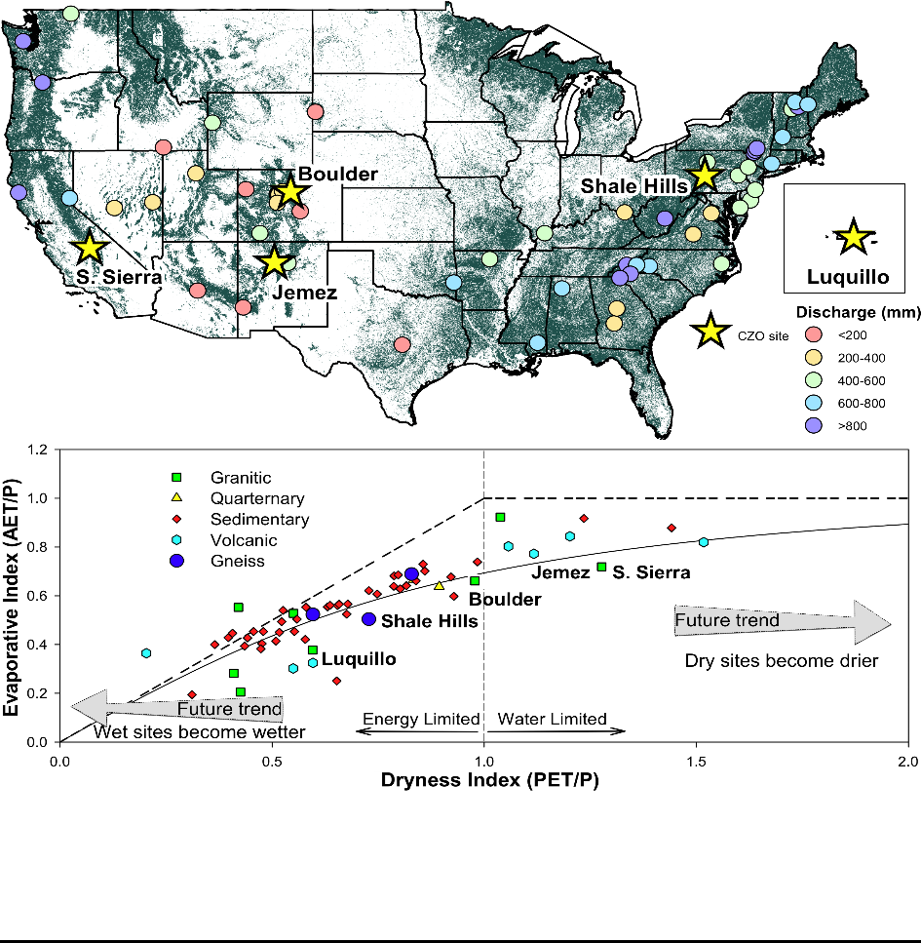

*Fig. 6. Location and hydrologic characteristics of 60 USGS HCDN watersheds and five CZOs. The sites cover most of the forest-dominated ecoregions of the U.S. and span a wide range of hydrological export.*

For the proposed research we will first categorize (i.e., cluster) sites based on climate, changes in precipitation chemistry (pH, ionic strength, sulfate) and CZ characteristics (e.g. soil and bedrock composition) and DOC export patterns, by using a suite of complex systems tools to analyze these combined data of variably spatial and temporal resolution. Mining these complex datasets for useful information is challenging with traditional statistical methods, because of missing data, imbalanced class outcomes, heterogeneity of drivers of infestation, non-independence of some features, and complex, possibly high-order, nonlinear interactions between many of the potential predictive features (Lin et al. 2013). We circumvent these typical issues and deal with the massive number of complex multivariate interactions by assuming that individual features (input variables) have main effects and use feature selection tools (e.g., logistic regression) and reduce the size of the feature set that is to be mined for higher order interactions (De Andrade et al. 1995; Enger et al. 2004).

One of the first steps will therefore be to identify features (i.e., identify potential drivers) common across the clustered USGS and HCND data. Our starting point will be a recently developed tandem evolutionary algorithm and Genetic algorithm approach. The two algorithms, developed by Co-PI Rizzo (Hanley et al. 2016), evolve sets of probabilistically significant multivariate epistatic interactions among input features (input variables) that are correlated with desired categorical outcomes. The datasets may include nominal, ordinal, and/or continuous features, missing data, imbalanced classes, and other complexities associated with Big Data. The algorithms adopt an age-layered evolutionary algorithm and generate conjunctive clauses to model multivariate interactions in datasets too large to be analyzed using traditional methods such as logistic regression. The method uses a novel hypergeometric probability mass function for fitness evaluation, and archives conjunctive clauses that are probabilistically significant at a given threshold, thus identifying strong complex multivariate interactions. This tandem approach has been validated on two synthetic epistatic datasets (Hanley et al. 2015; Hanley et al. 2016) and is applied to a complex real-world survey dataset motivated by the desire to mine data from a large survey. Once sets of significant features have been identified (i.e., strong multivariate interactions), these features may be post-processed using network analysis tolls (e.g., Bayesian networks) or passed into machine-learning clustering algorithms (Pearce et al. 2011) to collapse the high dimensional data into 2-D images to facilitate expert understanding. We will then link emerging patterns (e.g. clustering of acid impacted vs non-impacted) to test our hypothesis 1 and to potentially adapt our hypothesis or develop new ones.

**When and who:** The statistical analysis of external vs. internal drivers and presence/absence of stream water DOC response is the starting point of this project. A Ph.D. student, co-advised by Rizzo and Harpold, will begin data mining using universal computational methods for handling and describing large-scale data sets. The University of Vermont’s existing Complex Systems Certificate offers a great variety of core courses for graduate credit uniquely situated to support the student’s research and training.

**Deliverables:** The statistical analysis and merging of data will constitute 2 peer reviewed publications and part of the thesis of PhD student #1.

**5.2. How will we use a watershed hydrobiogeochemical model to test specific hypotheses on selected sites?**

**What:** While the previous step targets the regional scale, we will now zoom in to the catchment scale to investigate the role of soil aggregates in DOC release (hypothesis 2). This second step is based on the statistical analysis of external (climate, recovery from acidification) and internal (CZ structure) drivers for stream water DOC response, and we will select 3 catchments for process-based RTM modelling using RT-Flux-PIHM, the newly developed watershed hydrobiogeochemical modeling code (Bao et al. 2016). Catchments will be chosen to represent patterns identified with complex systems tools (5.1.) and based on the availability of data on hydrology, lithology, soil aggregate characteristics, as well as DOC data (this could be CZOs or USGS research sites). Note that results of step 1 could lead to the development of new hypotheses or adaptation of hypotheses 2 and we are prepared to accommodate this in our model design.

**How:** *Model setup, data reproduction, and analysis:* The model will be set up in RT-Flux-PIHM for 3 selected sites using spatial data from national databases including topography, land cover, soil type from USGS National Elevation Dataset (NED), the Soil Survey Geographic (SSURGO) database, and the National Land Cover Database (NLCD). Watershed discharge and water chemistry data will be used as constraints for obtaining parameters of hydrological and biogeochemical processes at the watershed scale. The output of calibrated models will include temporal and spatial distribution of state variables, including temperature, soil moisture, chemistry of waters (e.g., soil water, stream water, drainage water), reaction rates relevant to DOC, and fluxes. This rich information will allow analysis of ecohydrological and biogeochemical processes at the grid block (local) scale. At the watershed scale, rates and fluxes will be calculated based on mass balance. For example, DOC export rates at the watershed scale will be quantified by multiplying concentrations with discharge at the river mouth. The comparison of local and watershed scale information will allow identification of dominant processes and key controls at different spatial scales.

*Sensitivity analysis to identify key drivers:* After training the model with ground-truth represented by data, RT-Flux-PIHM will be run to test the sensitivity of model output to internal drivers including soil and DOC characteristics, as well as external drivers such as climate. The sensitivity analysis will identify key internal and external drivers that control DOC export and soil biogeochemical processes. It can also be used to quantify the relative dominance of topographic, climatic, land cover, and human activity control at each site. In addition, watershed scale characteristics, including dynamic connectivity, will be quantified using spatial distribution of soil moisture for different times using the framework in literature (Western et al. 2001). The linkage between DOC export and dynamic connectivity will be explored. The ultimate goal is to link DOC outfluxes to climate, watershed spatial characteristics (e.g. topography), as well as soil characteristics (e.g. mineralogy, metal content).

**When and who:** catchment scale RTM will be conducted by PhD student #2, hosted at Penn State and advised by Co-PI Li. In the first year, focus will be given to expand the capabilities of current RTMs to include the parameterization of e.g. aggregation and disaggregation processes in soils. One of the CZO sites (Shale Hills) is already fully modeled (Bao et al. 2017) and will serve as a testbed. In year 2 and 3 the models will be applied to simulate processes in 2-3 catchments.

**Deliverables:** We anticipate that at least two student-led, peer-reviewed publications will result from this part of our research activity, as well as part of the thesis of PhD student #2.

**5.3. How will we use experiments to test soil aggregate destabilization as mechanism of DOC liberation?**

**What:** Equally informed by statistical analysis (5.1.), we will select 5 sites to test the importance of soil C stabilization mechanism by characterizing soils (composition, mineralogy), aggregate composition and physical and chemical stability from riparian and hillslope soils. Data from this analysis will feed back to the statistical analysis and RTM (5.1. & 5.2) and will be used to select samples for column experiments to test hypothesis 2 and 3.

The importance of mineral soil in C stabilization and DOC production was already investigated by Kerr and Eimers (2012) who showed a relationship between soil water Ca2+ concentration decrease and with stream water DOC increases. The authors accompanied their observations with adsorption experiments where Ca ions addition increased sorption of DOC on mineral soils and attributed this to cation bridging. In this system, the presence of divalent cations was likely limiting, whether via aggregation or simple sorption. In another study by Hruška et al. (2009) ionic strength (I) increased with DOC, hence their results are consistent with the dispersion of colloidal organic matter when switching from low-pH & high-I to high-pH & low-I solutions (Stumm & Morgan 1996), even though the authors did not discuss the mechanisms in detail.

**How:** For soil characterization, we will sample riparian soils within 5 m of the active channel and hillslope soils at four several depths (0-15, 15-30, 30-45, 45-60 all in cm) with bucket augers. In order to capture the spatial variability of soil characteristics, we will collect and amalgamate 10 samples at 6 locations in each watershed (3 riparian, 3 hillslope) leading to 6 composite samples (integrating the characteristics of 60 samples) for each of the 5 sites (Nichols et al. 2002). The amalgamation will be done on field moist soils in plastic buckets to limit disturbance of soil aggregates and samples will be split in several sample subsets. One subset will be dried, ground (<50 μm), and analyzed for elemental composition including metal content using X-ray fluorescence (XRF). Mineralogy, especially typical aggregate stabilizers such as clay minerals and metal oxyhydroxides will be identified using X-ray diffraction (XRD). Another dried subset of samples will be analyzed for total organic carbon content using an Elemental Analyzer to determine the amount of organic C available for aggregation.

Organic rich composite samples will be analyzed for particle size distribution (PSD) using laser diffraction to determine the amount and size of soil aggregates. The physical aggregate stability will be determined with the density separation method, a laboratory extraction method that separates different aggregate constituents from each based on an increasingly aggressive physical treatment to identify different fractions (Golchin et al. 1994). Chemical aggregate stability will be assessed with sequential extractions that target labile organics and metal oxy-hydroxides (Land et al. 1999; Vázquez-Ortega et al. 2016). Solutes that are extracted along with the target extract are likely stabilized together.

To test the influence of solution chemistry on DOC release from soils, we will conduct column experiments on up to 5 representative soil samples (Perdrial et al. 2014b). For this we will pack soil samples into plastic columns (2.1 cm in length, 0.8 cm diameter) in duplicate and infiltrate them with a simulated soil water of varying pH and ionic strength to simulate acidification (pH 4, ionic strength ~ 0.001M) and recovery (pH 7, ionic strength ~ 0.0003M). We will then monitor inflow and effluent chemistry over 10-20 days in replicate. Solutes will be monitored for pH, anion composition (ion chromatography), cations (ICP-OES) and DOC (C analyzer). Once the experiment is completed we will characterize soil aggregates with the methods described above.

The results of the column experiments will be additionally modeled with RTM using the code CrunchFlow, which has been used to understand water-rock interactions and biogeochemical processes in various applications (Li et al. 2011; Li et al. 2010; Steefel et al. 2005): Column experiments will be set up using measured physical and geochemical properties of soil aggregates (e.g., elemental composition and surface area) at selected sites. Measured effluent aqueous geochemistry will be used to determine dominant reactions and reaction parameters associated with DOC-soil interactions. The reaction parameters include equilibrium constants and reaction kinetics of DOC sorption / desorption on soil surface. After reproducing column data for selected sites, the developed RTM will also be used to understand DOC-soil interactions in other sites without soil sampling using existing data on soil characteristics and aqueous chemistry. Reaction network and reaction parameters obtained here will be used to further inform watershed scale modeling.

**When and who:** Sample collection will be coordinated by a MS student and undergraduate helpers, followed by soil aggregate characterization and column experiments in year 2 and 3, supervised my PI Perdrial. RTM of experimental results will be conducted by PhD student #2 in year 3 (co-advised by Co-PI Li and PI Perdrial).

**Deliverables:** We anticipate that at least one student-led, peer-reviewed publication as well as the thesis of the MS student will result from the experimental part of our research activity. Another student led paper will focus on RTM of experiments.

**6. Results from previous NSF support**

1. **PI Perdrial** has received funding from VT EPSCoR Research Infrastructure Improvement (RII), $20,000,000 as co-I on *“Basin Resilience to Extreme Events (BREE)”* (06/16 - 05/21). The health of Lake Champlain is increasingly damaged by extreme hydrological events and this research targets strategies for improving water quality resilience. Several objectives of high **intellectual merit and broader impact** include i) the improvement of human and physical infrastructure to support research and education in VT, ii) the increase of diversity of people and institutions and iii) innovations. Since the project was only funded very recently, no papers have resulted from this activity yet. Products from another NSF-funded project (“Transformative Behavior of Water, Energy and Carbon in the Critical Zone: II. Quantifying the Interactions between Long and Short Term Processes that Control Critical Zone Services”, (10/13 - 10/18)) are listed:

1) **Perdrial JN**, Mcintosh JC, Harpold A *et al.* (2014a) Stream water carbon controls in seasonally snow-covered mountain catchments: impact of inter annual variability of water fluxes, catchment aspect and seasonal processes. Biogeochemistry*,* **118**, 273-290.

1. **Perdrial JN,** Perdrial N, Vazquez-Ortega A, Porter CM, Leedy J, Chorover J (2014b) Experimental assessment of fiberglass passive capillary wick sampler (PCap) suitability for sampling inorganic soil solution constituents. Soil Sci Soc Am J*,* **78**, 486-495.
2. **Perdrial JN,** Thompson AA, Chorover J (2015) Soil Geochemistry in the Critical Zone: Influence on Atmosphere, Surface- and Groundwater Composition. In: *Principles and Dynamics of the Critical Zone.* (eds Giardino JR, Houser C) pp Page., Elsevier.
3. Stielstra C, Brooks PD, Lohse KA(...) **J.N.Perdrial** *et al.* (2015) Climatic, Landscape, and Edaphic Controls on Soil Carbon Fluxes in Seasonally Snow Covered Forest Ecosystems. Biogeochemistry*,* **123**, 447-465.
4. Vázquez-Ortega A, **J.N. Perdrial**, A. Harpold *et al.* (2014) Rare earth elements as reactive tracers of biogeochemical weathering in forested rhyolitic terrain. Chemical Geology*,* **391** 19-32.

**Co-PI Rizzo** has received funding from several NSF directorates (EEID: BCS, DEB, and MRI) over the past 5 years. The most recent, is NSF: EEID-BCS - “Collaborative Research:Modeling disease transmission using spatial mapping of vector-parasite genetics and vector feeding patterns” Award #1216193, $2,462,002. **Intellectual Merit and Broader Impact:** This supports the development of spatially explicit models to understand the dynamics and map transmission risk of Chagas disease, a parasitic disease endemic to Latin America that afflicts an estimated 10 million people. Results to date have resulted in 6 publications (below) and numerous conference presentations.

1) Hanley, J.P., M.J. Eppstein, J.J. Buzas, and **D.M. Rizzo**, “Evolving Probabilistically Significant Epistatic Classification Rules for Heterogeneous Big Datasets”, *Proceedings in the 18th Annual Conference on Genetic and Evolutionary Computation*, Denver, Colorado July 20-24. 2016.

2) Hanley, J.P., E. Jackson, L.A. Morrissey, **D.M. Rizzo**, et al. “Geospatial and Temporal Analysis of Thyroid Cancer Incidence in a Rural Population”, Thyroid, doi: 10.1089/thy.2015.0039, 812-22, 2015.

3) Lucero D., W. Ribera, J.C. Pizarro, C. Plaza, R. Pena, L.W. Gordon, L.A. Morrissey, **D.M. Rizzo**, and L. Stevens, “Sources of Blood Meals of Sylvatic Triatoma guasayana near Zurima, Bolivia Assayed with qPCR and 12S Cloning”, *PLOS Neglected Tropical Diseases*, doi: 10.1371/journal.pntd.0003365, 2014.

4) de la Rúa, N., D.M. Bustamante, M. Menes, L. Stevens, M.C. Monroy, C.W. Kilpatrick, **D.M. Rizzo** et al., “Towards a Phylogenetic Approach to the Composition of Species Complexes in the North and Central American Triatoma, Vectors of Chagas Disease”, Infection, Genetics and Evolution, [doi.org/10.1016/j.meegid.2014.03.019](http://dx.doi.org/10.1016/j.meegid.2014.03.019), 24, pp.157-166, 2014.

5) Stevens, L., **D.M. Rizzo**, D.E. Lucero and J.C. Pizarro, “Household model of Chagas disease vectors (Hemiptera: Reduviidae) considering domestic, peridomestic and sylvatic vector populations”, Journal of Medical Entomology, doi: 10.1603/ME12096, 50 (4), pp.907-15, 2013.

6) Lucero, D., L.A. Morrisey, **D.M. Rizzo** et al, “Ecohealth interventions limit triatomine reinfestation following insecticide spraying in La Brea, Guatemala”, A J Am J Trop Med Hyg, doi: 10.4269/ajtmh.12-0448, 88 6), pp.630–637, 2013.

**Co-PI Harpold** has received a Post-Doctoral Fellowship under EAR-1144894, $170,000 (09/12-08/14), “*Improving Snow-Vegetation Interactions In Land Surface Models*”. **Intellectual Merit and Broader Impacts:** This project resulted in improved understanding of snow-forest interactions by synthesizing field data and performing modeling experiments across multiple sites. The project utilized the Critical Zone Observatory (CZO) network, where common observations of snowpack, hydrology, forest structure, and climate were collected in Colorado, California, and New Mexico. The overall project results indicated that improved model representation of forest structure is critical to effectively predicting water resources in diverse mountain forests and provided opportunities for graduate and undergraduate training, some of which are co-authors on the following products:

1) Broxton, P., **A.A. Harpold**, J. Biederman, P.D. Brooks, P.A. Troch, and N.P. Molotch. (2015) Quantifying the effects of vegetation structure on wintertime vapor losses from snow in mixed-conifer forests. Ecohydrology. doi: 10.1002/eco.1565. 2) **Harpold, A.A**., Q. Guo, N. Molotch, P. Brooks, R. Bales, J.C. Fernandez-Diaz, K.N. Musselman, T. Swetnam, P. Kirchner, M. Meadows, J. Flannagan, and R. Lucas. (2014) A LiDAR derived snowpack dataset from mixed conifer forests in the Western U.S. Water Resources Research. 50(3): 2749-2755. doi: 10.1002/2013WR013935.

3) **Harpold, A. A**., Marshall, J. A., Lyon, S. W., Barnhart, T. B., Fisher, B. A., Donovan, M., Brubaker, K. M., Crosby, C. J., Glenn, N. F., Glennie, C. L., Kirchner, P. B., Lam, N., Mankoff, K. D., McCreight, J. L., Molotch, N. P., Musselman, K. N., Pelletier, J., Russo, T., Sangireddy, H., Sjöberg, Y., Swetnam, T., and West, N. (2015). Laser vision: lidar as a transformative tool to advance critical zone science, Hydrol. Earth Syst. Sci., 19, 2881-2897, doi:10.5194/hess-19-2881-2015, 2015.4) Knowles, J.F., **Harpold, A.A**., Cowie, R., Zeliff, M., Barnard, H.R., Burns, S.P., Blanken, P.D., Morse, J.F., and Williams, M.W. (2015), The relative contributions of alpine and subalpine ecosystems to the water balance of a mountainous, headwater catchment. Hydrological Processes. 29: 4794-4808. doi: 10.1002/hyp.10526. 5) **Harpold, A.A**, N.P. Molotch, P.D. Brooks, R. Bales, M. Litvak, K. Musselman. And P. Kirchner. (2015) Snowmelt infiltration in mixed-conifer subalpine forests. Hydrological Processes. 29: 2782-2798. doi: 10.1002/hyp.10400.Harpold, A.A. and N.P. Molotch. Sensitivity of Soil Water Availability to Changing Snowmelt Timing in the Western U.S. Geophysical Research Letters. 42. 10.1002/2015GL065855

**Co-PI Li** has received several NSF funding support. **EAR–1331726**: “Using the Susquehanna–Shale Hills CZO to Project from the Geological Past to the Anthropocene Future” (co-PI, PI Brantley, $4,900k, 10/01/13 – 09/30/18), where the PI is leading the modeling component for SSHCZO. *Intellectual merit:* The PI’s group has developed the code RT-FLUX-PIHM that enables the coupling of land-surface interactions, hydrological processes, and subsurface reactive transport at the watershed scale. This code will be used in the current proposed project. Two manuscripts out of this project are in the final stage of review processes (Bao et al. 2016; Li et al. 2016a). *Broader Impacts:* The PI hosted two REU students in summer 2016: Connor Martin and Perry Silverhart. **EAR–1414558**: “NSF Workshop: Expanding the Role of Reactive Transport Modeling (RTM) within the Biogeochemical Sciences” (co-PIs K. Maher and A. Navarre-Sitchler, $50k, 03/01/14 – 02/28/15). *Intellectual merit:* The project outcome includes a workshop, a short Eos report (Li et al. 2014) and a vision paper on Earth Science Reviews (Li et al. 2016b). *Broader Impacts:* The PIs carried a survey on the current status of RTM education. **EAR-1452007**: “Redefining surface area: Understanding Reactive Interfaces in Heterogeneous Porous Media” (PI, $193,050, 07/01/15 – 06/30/18). *Intellectual merit:* Outcome includes a submitted manuscript (Wen & Li 2016) and others in preparation. *Broader Impacts:* The PI is currently developing an online RTM course. The graduate student on this project led a SEEMs team of high school students who won first prize in summer research presentation competition.

**7. Intellectual Merit**

The combination of statistical and process-based modelling with experiments to bridge scales varying >10 orders of magnitude is novel and potentially transformative. We do not only tackle a highly debated topic in catchment biogeochemical sciences but furthermore work towards providing a template for the integration of scales, disciplines and approaches.

**8. Expertise based project management**

The proposed research will be accomplished through an interdisciplinary team effort among the four PIs with significant expertise in advanced statistics (Guilbert et al. 2015; Howard et al. 2016; Xu et al. 2015), RTM (Li et al. 2011; Li et al. 2016b; Li et al. 2010), catchment hydrology and biogeochemistry (Harpold et al. 2010a; Harpold et al. 2010b; Perdrial et al. 2014a), the analysis of aggregates and column experiments (Perdrial et al. 2012; Perdrial et al. 2014b; Perdrial et al. 2009) and cross-CZO work (Harpold et al. 2013; Harpold et al. in press; Perdrial et al. 2012).

Two PhD and one MS student will be collaboratively advised. The MS student and PhD student 1 will be supported for two years and PhD student 2 for 3 years (Fig. 7). As the lead PI, Perdrial will be responsible for project oversight and reporting, coordination of sample collection, soil aggregate characterization and column experiments. Rizzo will lead the modeling efforts using complex systems tools in close collaboration with Harpold, who will consult with hydrologic process knowledge and data mining and Perdrial, who will consult with biogeochemical process knowledge. Li will lead all RTM efforts in close collaboration with the other (co-)PIs. Annual meeting amongst all (co-)PI’s and students will be held during the AGU fall meeting in San Francisco. Furthermore, travel by Harpold, Li and PhD student #2 to UVM for annual project meetings will ensure optimal advising and collaboration.

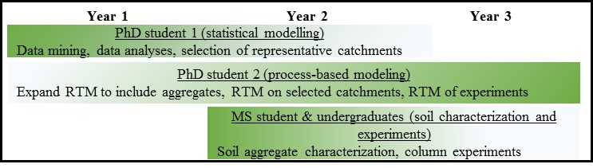

*Fig. 7. Timeline of proposed work.*

**9. Broader Impacts**

Advances in understanding catchment scale C dynamics have a broad impact due to the linkages between C cycling and observed and predicted climate change. Interdisciplinary training in complex systems and the use of multiple approaches (ranging from field observations to lab experiments and modelling) is therefore crucial for the next generation of problem solvers. The proposed research includes this type of training for multiple graduate and undergraduate students that will work in close collaboration with the PI’s as domain experts, providing a powerful way of searching for, hypothesizing, and extracting explanatory, mechanistic stories underlying complex systems.

Furthermore, we propose in collaboration with Dr. Regina Toolin (Associate Professor of Science Education in the College of Education at UVM) and the Sustainability Academy in Burlington (minority serving K-5 elementary school), to develop and administer a professional development workshop for Vermont’s K-5 teachers in Fall 2018. This one-day workshop will be a starting point to explore *"The critical zone as classroom for sustainability education"* and will be held at the Davis Center at the University of Vermont with the goal to: i) provide professional development for K-5 educators on the CZ as a framework for sustainability learning and ii) to begin to develop teaching modules with participating educators for the appropriate K-5 level. We believe that the Earth’s surface, as it is understood in CZ science, is an ideal environment for K-5 hands-on education in systems thinking including concepts such as thresholds (e.g., rain versus snow), relationships (e.g., snow accumulates water), feedbacks (e.g., more snow leads to less warming) and complex behaviors (e.g., less snow in the winter yields dry summers). Furthermore, the CZ provides opportunities for place based learning and inquiry of environmental, social and economic sustainability.

We will advertise this workshop to K-5 educators in the Burlington School District via list serves and will furthermore will reach out to the network of the Sustainability Academy. During the morning session, educators will improve their knowledge on interdisciplinary CZ science (led by Perdrial) and skills in using complex systems data (led by Rizzo). The afternoon will be used to develop sustainability teaching activities and lesson drafts that teachers co-design with the help of the workshop instructors (led by Toolin and faculty of the sustainability academy). To increase teacher buy-in and to increase the probability that developed materials are used in the class room we will focus integrating the CZ and sustainability aspects into existing K-5 curriculum requirements. We are convinced that the synergistic experience in complex systems, CZ science, teaching of adult learners (PIs) and sustainability education will allow for the effective development of CZ teaching materials and activities at multiple levels.

**Assessment and dissemination:** We will assess the effectiveness of the workshops with a survey at the end the workshop day. Teaching materials will be tested by faculty of the sustainability academy in their classroom and adapted as necessary. Furthermore we will check in with workshop participants twice during the school year to assess if and how the workshop outcomes are integrated. Results of this assessment will be used to for the planning of following outreach activities by Perdrial. Successful activities will be made publicly available on the VSTEM website (<http://vstem.w3.uvm.edu/>). Even though the workshop will be held in Vermont, outreach by PIs Harpold and Li will aim for the dissemination of teaching materials to schools in their respective home states as well (NV and PA).